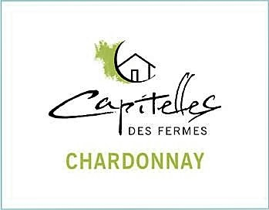

- Terroir: The terroir is made up of clay and limestone and sits on three sites that are roughly 380m above sea level.
- Climate: The valley has a Mediterranean climate with mountain influences, and experiences drastic fluctuations in temperature between night and day during the maturation period.
- Varietals: 100% Chardonnay.
- Vinification: After harvest the grapes are pressed and then the juice is then left to settle and clarified at low temperatures before fermentation takes place at a temperature of no more than 18˚C. Finally, the wine is aged on the lees and undergoes malolactic fermentation in steel, until February.
- Tasting notes: This wine is a brilliant yellow, with flashes of green. It has a fruity and flowery nose, and is a well-balanced and structured wine on the palate, with a solid expression of the soil in which it has grown, and a citrus finish. Service & food pairing Serve at lightly chilled (10-13˚C). The wine can be appreciated alone but goes equally well with grilled fish, salmon or goat cheese

